**Technical manual**



Juan Manuel Rojas Camargo

Servicio Nacional De Aprendizaje Sena

Ficha: 2281967

Neiva-Huila

2022

**Contents**

Page3….. Introduction.

Page(4-8) Instructions for the use of the information system.

Page9……Maintenance recommendations.

Page10.......Glossary

**Introduction**

This manual is based on an information system that builds a web application which was designed for the public, where the client can register and be able to access the platform designed to be able to purchase the product. It is a system with low visual complexity and very dynamic for the user.

**Instructions for the use of the information system**

For the configuration of the software the following is necessary:

**Back-end**

Install Microsoft .NET framework version 4.6.2, C# programming language. A web api with REST services was exposed; Post, Put, Get, Delete.

Architecture.

Design patterns are used, MVC. Separating the visual from the logical. In the Controller folder are the services exposed for use.

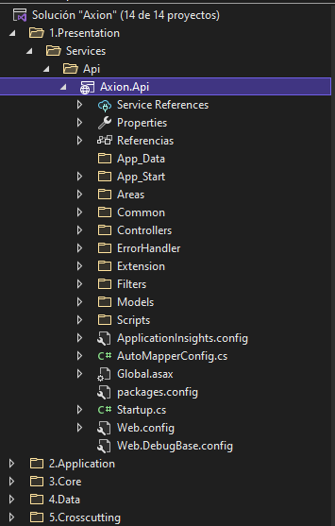

Setting

In the “Web.DebugBase.config” file. In the “<connectionStrings>” section, modify the connection string to the database

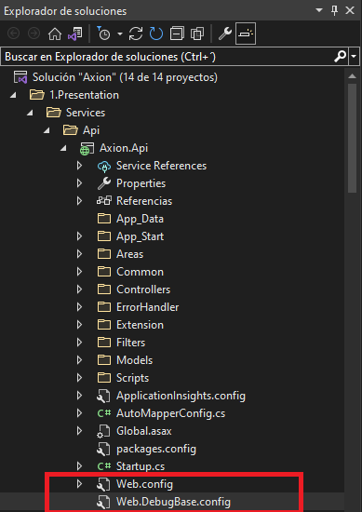

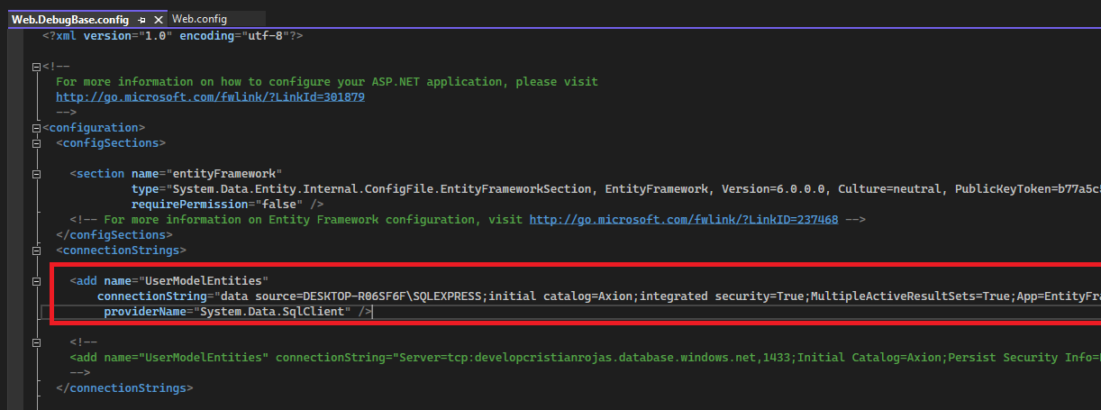  
  
Set as startup project “Axion.Api”, by default it has port 54499; <http://localhost:54499/>

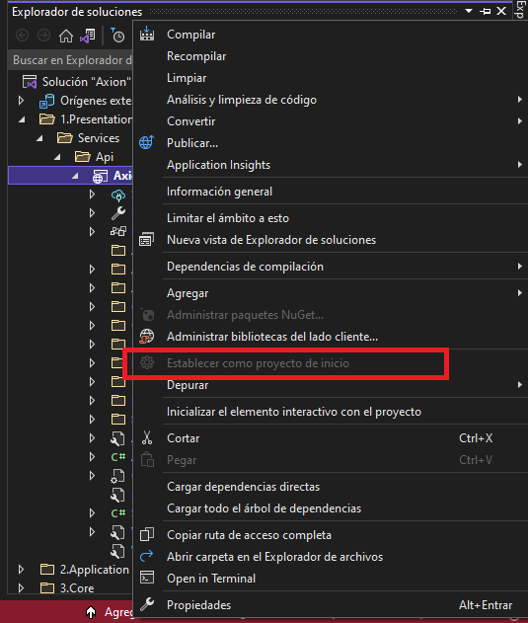

**front-end**

Developed with the Google framework "Angular", version 12.2.4

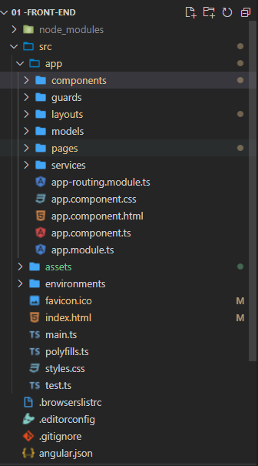

Setting

You must have Node js https://nodejs.org/en/ installed on the local machine, then run the “npm install” command, which allows us to install all the dependencies to run the project.

Command execution example; Find the source folder of the project

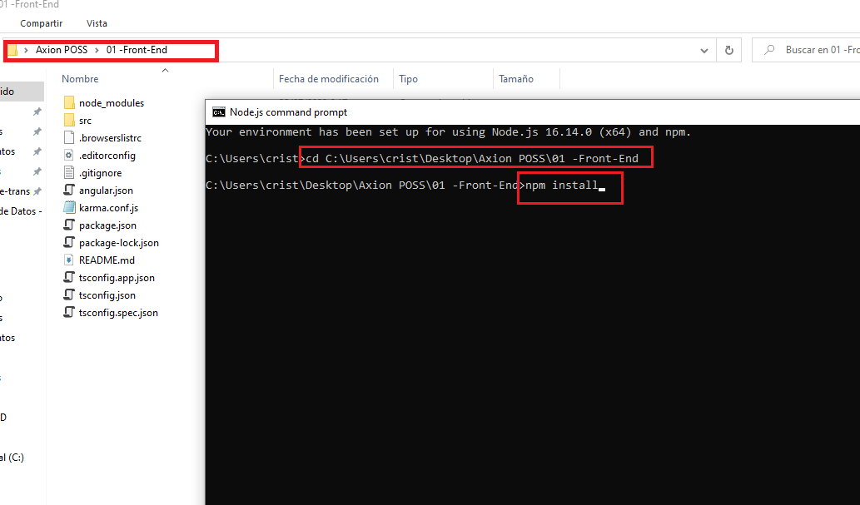

To run the project is the command "ng serve -o", it is important to be in the physical path of the project when executing the command.

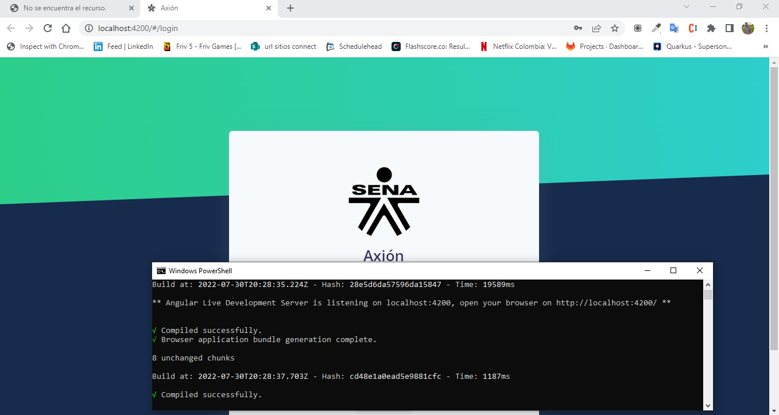

Note: Important to be able to use the project, the back-end must be running

**Maintenance recommendations.**

To run the software we must do the installation and configurations mentioned above since the Back-end and the Front-ent are compiled to be able to run.

Take into account the versions of the frameworks because if we install an old version an error is generated instantly

**Glossary**

.**User:** he is the one who can order, move and restructure a system.

**Front-end**: es la parte de un sitio web que interactúa con los usuarios, por eso decimos que está del lado del cliente.

**Back-end:** it is the part that connects with the database and the server that the website uses, that is why we say that the backend runs on the server side

**Software:** It is the set of programs or applications, instructions and computer rules that make the operation of the equipment possible.

**Framework:** it is a previous structure that can be used to develop a project.